TimeSprite

Status Reports and Project Submissions

Date: 08/10/2015 to 15/10/2015

University of the Pacific

COMP 188, Senior Project, 2015 Fall ---Yunpeng Zhang

Contents

2 Project Schedule 2

3 Currents Status 3

3.1 Finished Tasks 3

3.2 Falling being schedule 3

4 Plan for next work period 4

4.1 Task for next work period 4

5 Challenges and concerns 5

6 updated artifacts 6

# Project Schedule

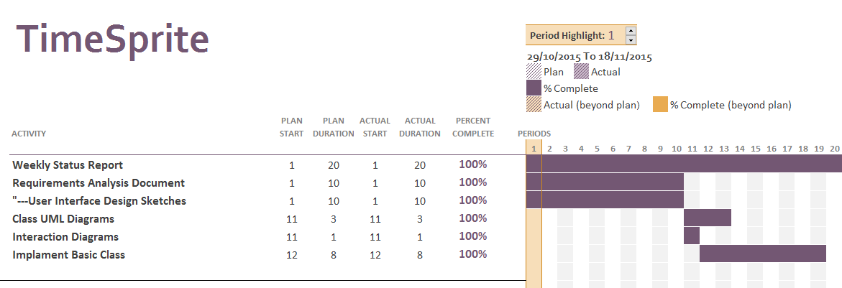

# Currents Status

## Finished Tasks

* Weekly Status Report
* User Interface Design Sketches
* Class UML Diagram
* Interaction Diagrams
* Implement Basic Class

## Falling being schedule

Finished all schedule tasks

# Plan for next work period

## Task for next work period

* Try to understand CVCalendar Library
* Finish System Design Document
* Look up Swift Document, understand the delegate
* Update Requirement analysis document

# Challenges and concerns

* Need focus on Swift Language
* Try to understand extend library

# updated artifacts

* Include Basic User Interface
* Class UML Diagrams
* Interface Integration